CENG4480 – Embedded System Development and Applications

Lab6 – Face Recognition and Pose Estimation

Please edit this file directly but submitted a PDF version to blackboard finally.

Member 1 Name: SID:

Member 2 Name: SID:

# Prepare

**Material:**

Raspberry Pi

Camera

**Reference:**

<https://www.superdatascience.com/blogs/opencv-face-recognition>

<https://shumeipai.nxez.com/2018/03/09/real-time-face-recognition-an-end-to-end-project-with-raspberry-pi.html>

https://core-electronics.com.au/guides/pose-and-face-landmark-raspberry-pi

**Reminder:**

1. Please download source codes from piazza.
2. You do not need to upload any code.

Please replace the sample photos with your own results and answer the questions if need.

**Part 1: Face Detection and Recognition**

**Task 1. Face Detection (10)**

Run the script: ‘*face_detection.py*’, to test the face detection function. (You need to put any two different photos of the face detection results).

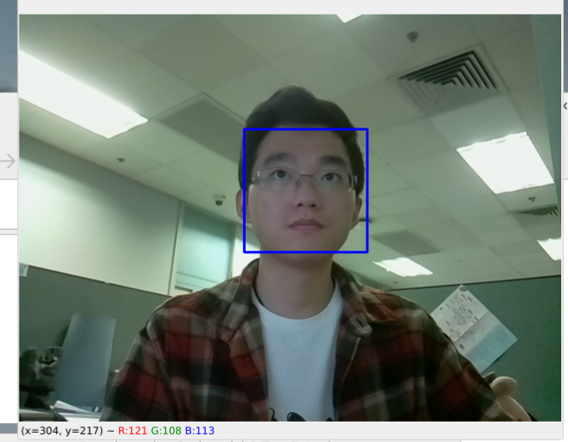 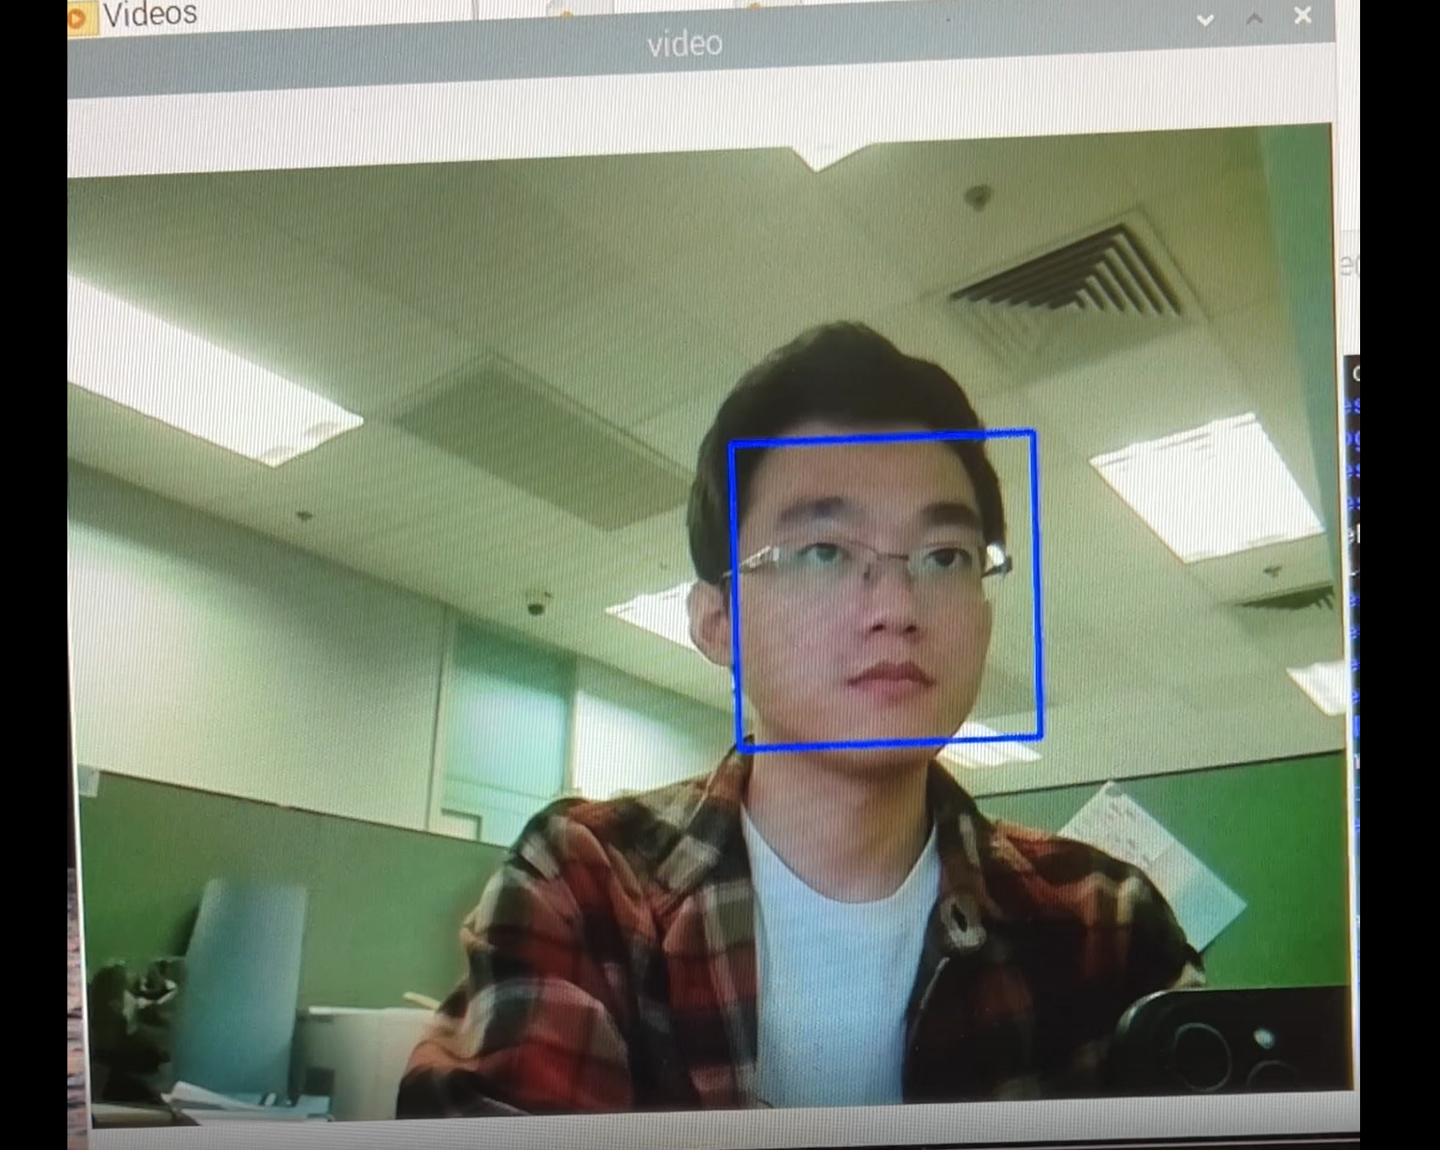

**Task 2. Eye Detection (15)**

Change the classifier (.xml) file to build different CascadeClassifier. In this part, you need to add a new classifier for eye detection. Specifically, you need to fill in the blanks in the provided script: ‘*face_eye_detection.py*’. In this part, the script can detect face and eyes simultaneously (You need to put any two different photos captured by the camera here).

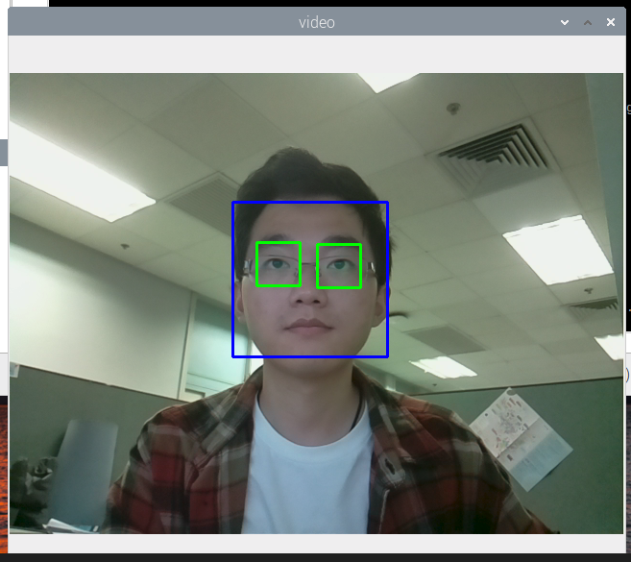 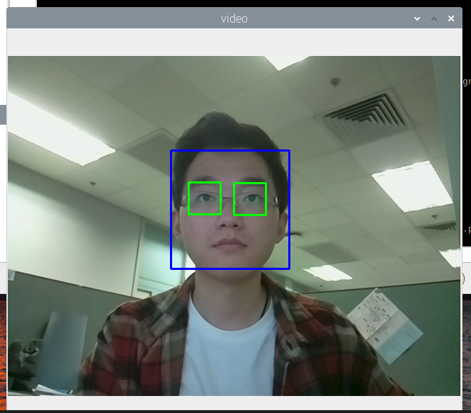

(They should be different.)

**Task 3. Smile Detection (15)**

Change the classifier (.xml) file to build different CascadeClassifier. In this part, you need to add a new classifier for smile detection. Specifically, you need to fill in the blanks in the provided script: ‘*face_smile_detection.py*’. In this part, the script can detect face and smile simultaneously (You need to put any two different photos captured by the camera here).

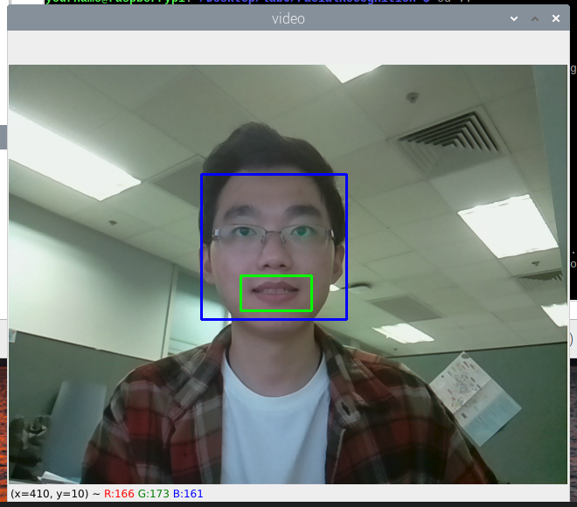 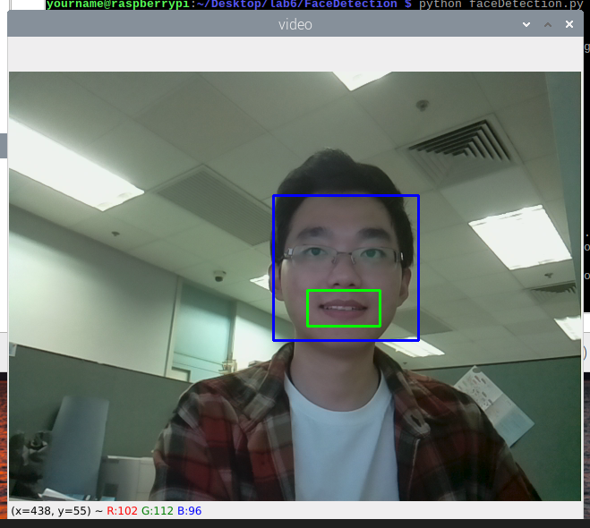

(Please replace the above photos with yours.)

**Task 4. Gather Data for Face Recognition (20)**

Use the script ‘*gathering_data.py*’ to collect faces of any two or three different persons (e.g., you and your partner), and put them into the ‘*dataset*’ folder. (To protect your privacy, you can provide only your own photos with masks. The data will only be used for checking assignments).

Note that:

1. In the ‘dataset’ folder, there are some photo examples, you need to delete all of them before you start gathering your own face data.
2. The gathered data will be automatically stored in the ‘*dataset*’ folder.
3. When you run the fathering_data.py script, you are required to enter the face ID for each person’s face. Please start from 1 to assign the face ID, cause 0 is pre-assigned to ‘None’ face. After enter the number, the script will automatically get the face data. Tips: when gathering the face data, you’d better ensure there is only one person in the scope.

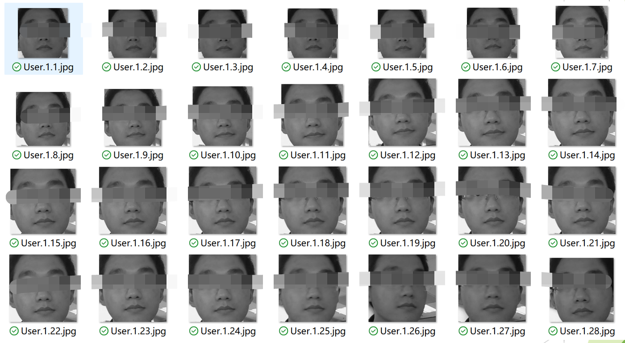

(Please replace the above photo with yours.)

**Task 5. Train Recognizer and Do Face Recognition (20)**

Use the script ‘*train_recognizer.py*’ to train the face recognizer with the collected photos. And use the script ‘*face_recognition.py*’ to do real-time face recognition. (To protect the privacy, you can provide the photos with masks. These photos should contain more than one person. The data will only be used for checking assignments. Please provide any two different photos).

Note that:

1. If you want to show your name on the face box, you need to change the pre-defined names in the script: face_recognition.py.
2. Please change the name accordingly. That is, you need to follow the face ID of each person’s face to modify the name list. For example, when I was gathering the faces, my face ID is 1, so I change the second (list index is 1) to ‘Xiangyu’.
3. Delete all the names from the name list, if they are not gathered to the dataset.

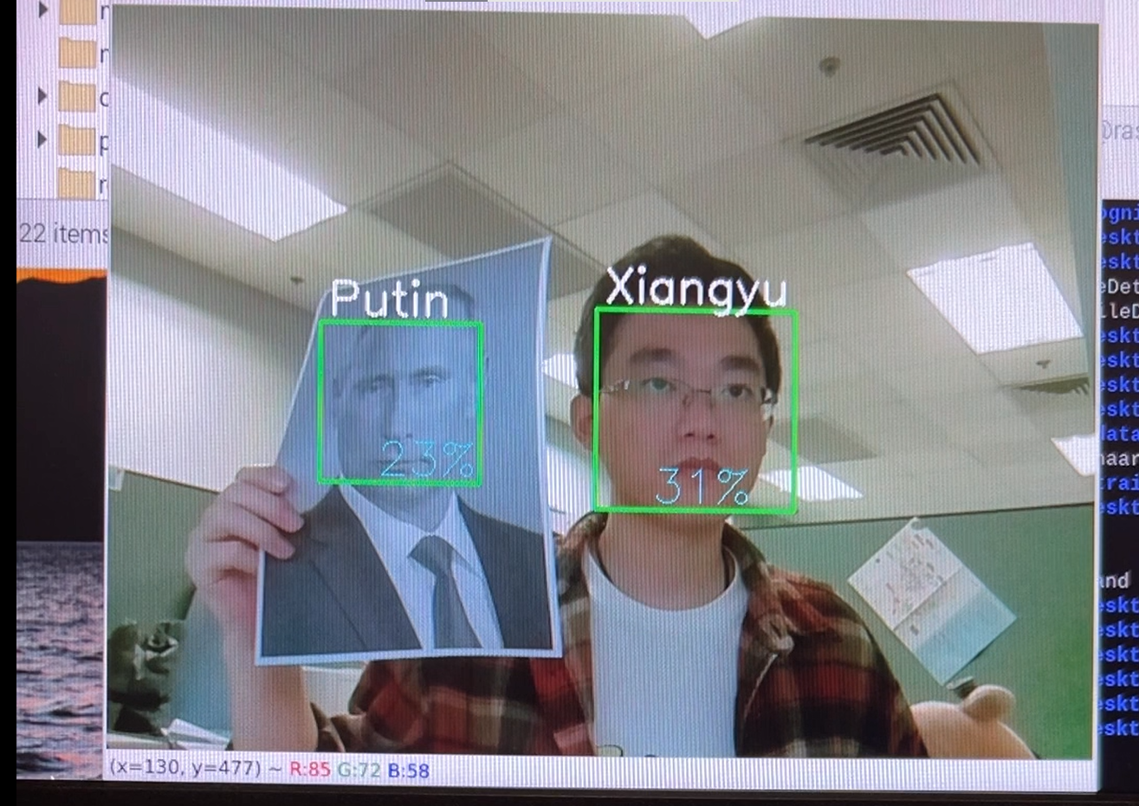 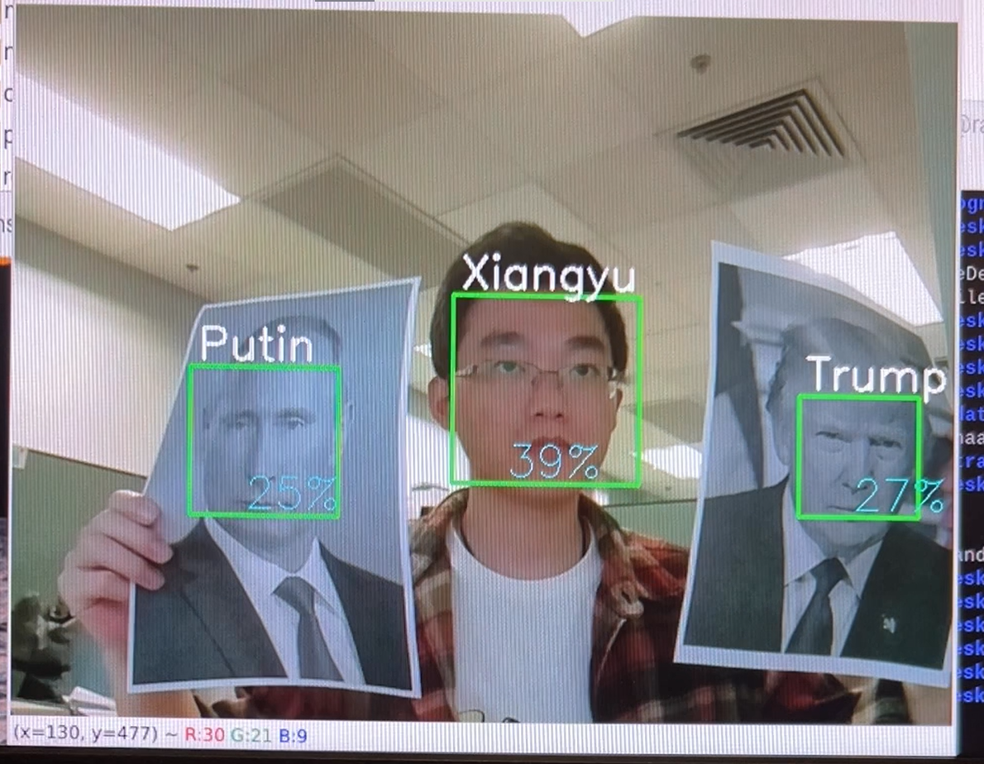

(Please replace the above photos with yours.)

**Part 2: Pose Estimation**

**Task 1. Pose Estimation (20)**

Use the script ‘*pose_estimation.py*’ to do real-time pose estimation. (To protect the personal privacy, you can provide the photos with masks. The data will only be used for checking assignments. One person in the photo is enough. Please provide any two different photos with different postures).

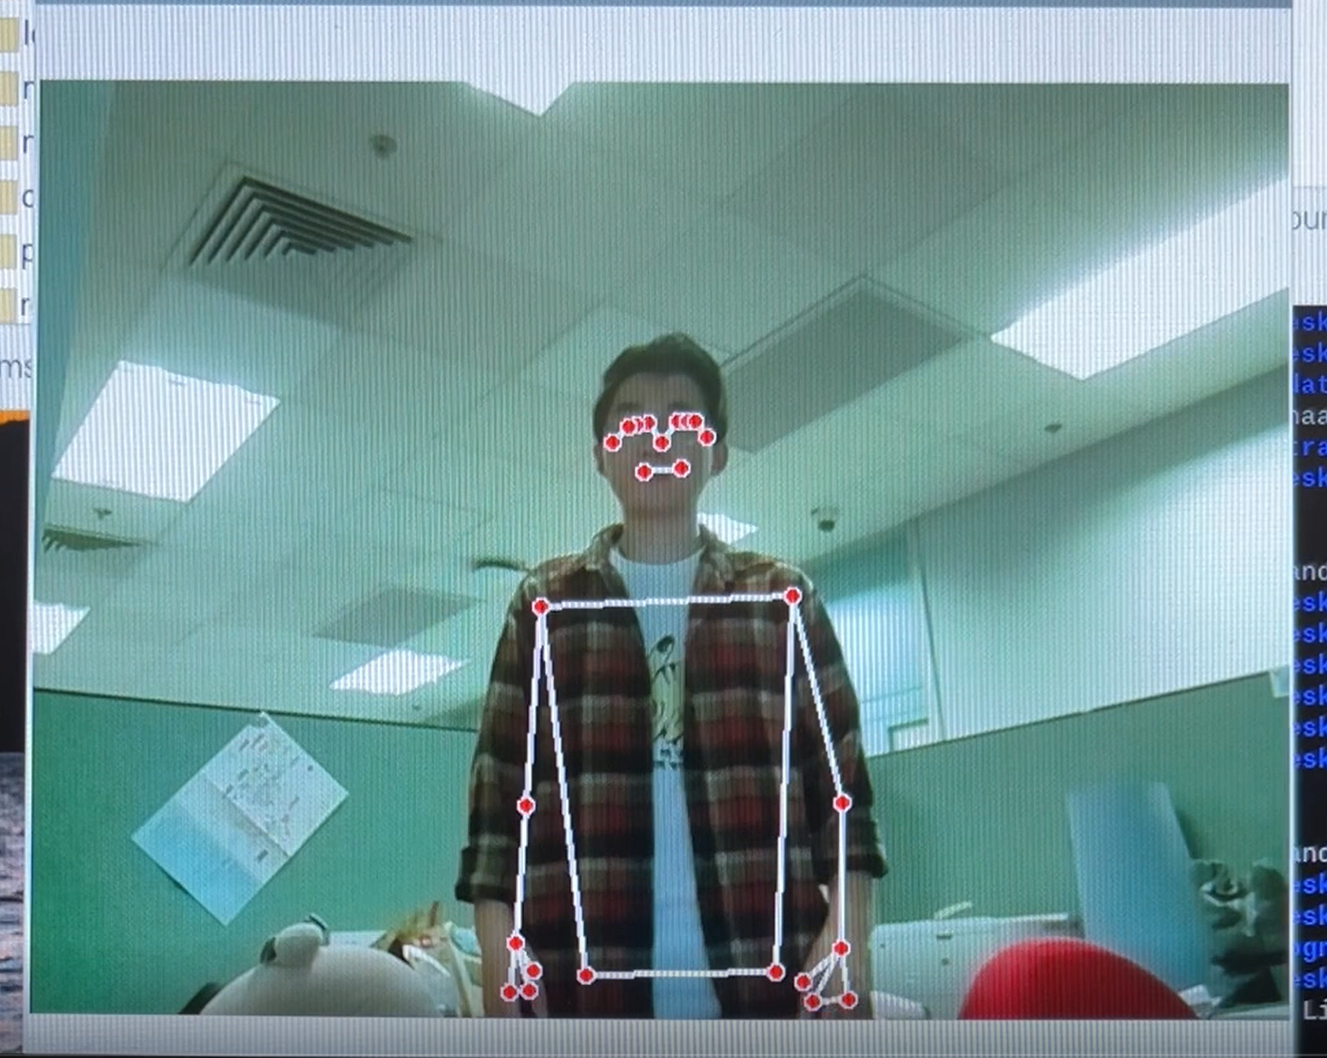 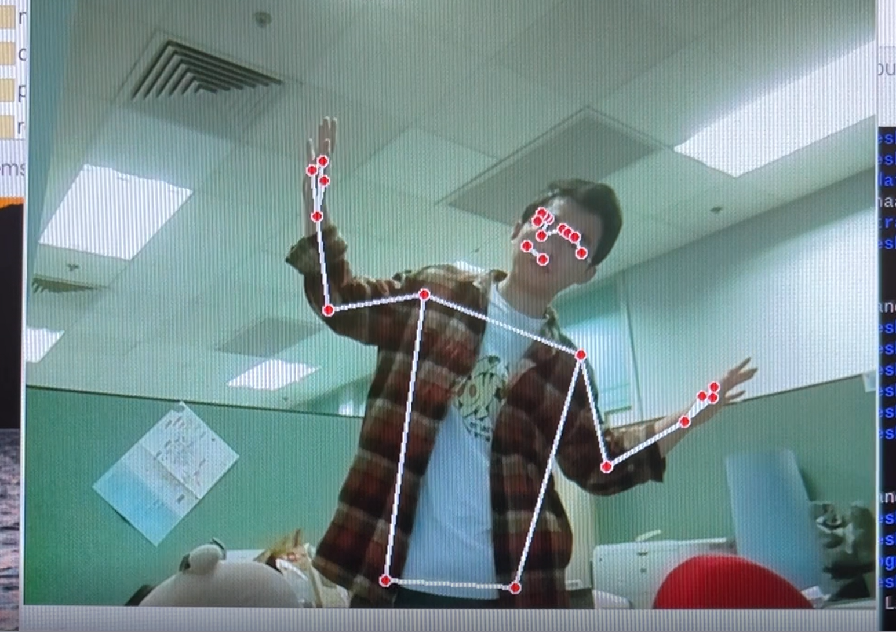

(Please replace the above photos with yours.)